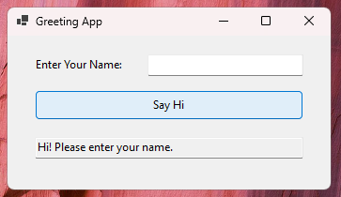

private void btnGreet_Click(object sender, EventArgs e)

{

string name = txtName.Text.Trim();

if (string.IsNullOrEmpty(name))

{

txtOutput.Text = "Hi! Please enter your name.";

}

else

{

txtOutput.Text = $"Hi {name}!";

}

}